Optimization of Banking Sector Stock Trading Strategies in Vietnam through Algorithmic Approaches and Moving Average Techniques
Nguyen Anh Tu,Phung Vuong Buu Khang
ªDepartment of Banking, Ho Chi Minh City University of Banking
^{b}High Quality Program of Banking and Finance, Ho Chi Minh City University of Banking
*Corresponding authors email: tuna@hub.edu.vn

Nguyen Anh Tu:
Orcid:
Optimization of Banking Sector Stock Trading Strategies in Vietnam through Algorithmic Approaches and Moving Average Techniques
Abstract:
This study aims to develop and validate an optimized portfolio trading strategy for Vietnamese banking sector stocks over the period from January 1, 2015, to August 20, 2025. The proposed methodology integrates the technical indicator of Moving Averages (MA) with advanced optimization algorithms, including Simulated Annealing (SA), Genetic Algorithm (GA), and Bayesian Optimization (BO). First, portfolio weights are optimized using these algorithms with the objective of maximizing the Sharpe Ratio. Subsequently, the short- and long-term parameters of the MA are exhaustively calibrated through Grid Search to identify effective configurations. Trading signals are then aggregated via a Top-K Voting scheme, thereby constructing the banking stock portfolio. The findings indicate that SA, GA, and BO all yield significant improvements in risk–return performance, with SA generally delivering more stable outcomes. From a technical indicator perspective, the Weighted Moving Average (WMA) outperforms both the Simple and Exponential Moving Averages across most validation periods. The study contributes by providing a reproducible analytical framework and offering practical implications for investors in combining quantitative technical analysis with modern optimization algorithms to enhance portfolio efficiency.
- Introduction
The Vietnamese financial market has been expanding rapidly, with the banking sector consistently regarded as one of its central pillars. Bank stocks account for a large proportion of total market capitalization and trading volume, and they attract significant attention from investors seeking profit opportunities. At the same time, increasing competition within the financial sector and frequent fluctuations in banking equities create both opportunities and risks for investors. These conditions underscore the necessity of developing effective trading strategies to optimize returns and mitigate risks. Technical analysis, particularly strategies based on Moving Averages (MA), has become one of the most widely adopted tools for financial trading worldwide (Mazumder et al., 2023).
Financial markets, including bank equities, are complex systems characterized by non-linearity, instability, and continuous change. Their movements are influenced by multiple factors—macroeconomic news, political events, and global market dynamics—which make prices highly sensitive and difficult to predict (Leles et al., 2019). In such a volatile environment, investors must rely on systematic methods and rigorous data analysis rather than subjective judgment. The use of moving averages to smooth price data, identify trends, and generate buy–sell signals allows investors to base their trading decisions on historical evidence and quantitative models. In this respect, technical analysis can serve as a breakthrough tool, supporting not only trading decisions but also innovations in automated investment systems and risk management practices (Gai et al., 2018).
Applying moving averages to bank stocks in Vietnam provides several advantages. First, they enable the identification of potential price trends and suitable entry and exit points. Second, when combined with other indicators, MA strategies enhance the accuracy of signals and reduce uncertainty in decision-making. Finally, they improve risk management by allowing investors to apply flexible strategies adapted to different market conditions (Nguyen, 2015). However, MAs are not flawless. In sideways markets with no clear trend, moving averages often generate false crossovers that lead to unprofitable trades. Such repeated small losses—commonly referred to as “whipsaw trades”—occur when signals are too frequent within narrow price ranges, thereby reducing overall effectiveness (Kan et al., 2024).
Another limitation lies in the absence of a universal MA strategy. Different types of moving averages—Simple Moving Average (SMA), Exponential Moving Average (EMA), and Weighted Moving Average (WMA)—exhibit distinct characteristics and performance depending on market conditions, volatility levels, and investor risk tolerance. For Vietnamese bank equities, which are highly liquid but strongly influenced by macroeconomic factors such as monetary policy and credit cycles, it is crucial to determine which MA configuration yields the best trade-off between return and risk. Nevertheless, current studies remain scarce: while MA-based trading has been extensively analyzed in international markets, there is little systematic comparison of SMA, EMA, and WMA applied to Vietnamese bank stocks. Moreover, prior work rarely incorporates a comprehensive optimization framework that evaluates MA strategies in combination with portfolio-level risk–return trade-offs.
The present study addresses this gap by proposing an integrated approach to optimize trading strategies for Vietnamese bank equities. Specifically, it combines MA-based technical signals with portfolio optimization techniques to maximize the Sharpe Ratio, which measures excess return relative to risk. The methodology involves two key dimensions: first, identifying optimal MA short–long parameter pairs for individual stocks, and second, optimizing portfolio weights using advanced algorithms such as Genetic Algorithm, Simulated Annealing, and Bayesian Optimization. Through backtesting, these strategies are evaluated under realistic market constraints, including T+2 settlement rules, transaction costs, stop-loss mechanisms, and cool down periods.
This research makes dual contributions. From an academic perspective, it enriches the literature on MA-based strategies by providing empirical evidence from an emerging market and by systematically comparing SMA, EMA, and WMA within the Vietnamese banking sector. From a practical perspective, it offers investors and financial institutions actionable insights for portfolio construction and trading execution. By presenting a rigorous framework for combining technical analysis with quantitative optimization, the study aims to support both individual investors and institutional actors in enhancing risk-adjusted returns and ensuring more resilient decision-making.
In summary, this research seeks to fill an important gap in the understanding of MA strategies in Vietnam’s financial market. By focusing on the banking sector, where volatility is pronounced yet liquidity is high, the study aims to demonstrate how systematic optimization of MA-based strategies can improve both profitability and stability in investment outcomes.
- Review of related literature
  - Moving Averages (MA)
In technical analysis, moving averages (MA) are widely used indicators that smooth price series, filter out noise, and generate clearer trading signals (Johnston et al., 1999). The three most common types are the Simple Moving Average (SMA), Exponential Moving Average (EMA), and Weighted Moving Average (WMA). The SMA is the arithmetic mean of prices over a fixed period; it is simple and effective for long-term trends but responds slowly to new changes. The EMA applies greater weight to more recent prices, allowing faster responsiveness but also greater susceptibility to short-term noise (Ojha & Saxena, 2023). The WMA linearly weights observations by recency, balancing the characteristics of SMA and EMA, offering both responsiveness and stability (Hansun, 2013).
  - Modern Portfolio Theory (MPT)
Proposed by Markowitz (1952), Modern Portfolio Theory (MPT) forms the foundation of contemporary portfolio management. Its central principle is diversification: instead of maximizing expected returns alone, an optimal portfolio balances expected return and risk. Expected return is evaluated together with variance or standard deviation, and combining low-correlated assets can yield desired returns with lower risk (Surtee & Alagidede, 2023). The concept of the efficient frontier represents the set of optimal portfolios where no portfolio can achieve higher returns without incurring additional risk. Measures such as the Sharpe ratio are frequently employed to assess performance.
In this study, MPT is applied to optimize bank-stock portfolios in Vietnam. Because bank equities often display high correlations due to macroeconomic influences such as monetary policy, interest rates, and credit cycles (Širůček & Křen, 2015), careful allocation of weights is necessary to avoid concentration risk. Optimization algorithms including Simulated Annealing, Genetic Algorithms, and Bayesian Optimization are utilized to determine optimal weights, with the objective of maximizing the Sharpe ratio while maintaining a balanced risk–return profile.
  - Technical Analysis and Application to Bank Stocks
Technical analysis uses price and volume data to forecast future price movements (Zhang & Zhang, 2009). For bank stocks, moving averages are commonly used to identify market trends. When prices move above an MA, this indicates an upward trend; conversely, when prices fall below, a downward trend is implied (Raudys & Pabarškaitė, 2018).
Trading strategies based on MAs include the Moving Average Crossover, combinations of MA with price action, and the application of algorithmic trading. SMA is often used to detect long-term support and resistance (Lê & Nguyễn, 2024). EMA is more sensitive and suitable for short-term trading, for instance through EMA20–SMA50 crossovers that signal buy or sell opportunities (Dinesh et al., 2021). WMA strikes a balance between sensitivity and stability, making it effective when markets exhibit clear directional trends (Liyanagamage & Madusanka, 2021).
Integrating MA-based technical analysis with portfolio optimization theory enhances both trading performance and risk control. Advances in financial technology, particularly artificial intelligence and machine learning, enable automated execution that eliminates emotional bias, thereby increasing accuracy and objectivity in investment decisions (Xiao et al., 2020).
  - Optimization Algorithms in Portfolio Management
The portfolio weight optimization problem is inherently nonlinear, high-dimensional, and often characterized by multiple local optima, making traditional analytical approaches insufficient in practice. Consequently, modern metaheuristic algorithms have been increasingly applied in finance to enhance portfolio efficiency under risk–return trade-offs. In this study, three optimization techniques are emphasized: Simulated Annealing (SA), Genetic Algorithm (GA), and Bayesian Optimization (BO).
Simulated Annealing (SA). SA was first introduced by (Kirkpatrick et al., 1983), inspired by the metallurgical annealing process in which a material is heated and then slowly cooled to reach a state of minimal energy. The algorithm allows occasional acceptance of inferior solutions to escape local optima, gradually converging toward the global optimum. (Cerny, 1985) extended this approach and demonstrated its effectiveness in solving complex optimization problems. Within the financial domain, SA has been valued for its flexibility and ability to manage large, constrained search spaces, making it suitable for determining optimal portfolio weights under volatile market conditions.
Genetic Algorithm (GA). GA, originally proposed by (Holland & Book, 2015), is an evolutionary algorithm that simulates Darwinian natural selection. Candidate solutions, or “individuals,” evolve through crossover, mutation, and selection operations to produce successive generations. This process enables GA to explore vast solution spaces and converge on near-optimal solutions for complex problems. (Goldberg, D. E., 1989) expanded GA into a comprehensive optimization framework. In portfolio management, GA has proven effective in risk–return optimization, with (Metaxiotis & Liagkouras, 2012) reviewing applications of GA and other multiobjective evolutionary algorithms and highlighting their significant contribution to solving real-world portfolio selection problems.
Bayesian Optimization (BO). This is a probabilistic optimization method in which the objective function is modeled using surrogate models such as Gaussian Processes. BO employs an acquisition function to balance the exploration of new candidate solutions with the exploitation of promising regions. It is capable of producing stable and accurate results while requiring fewer evaluations compared to conventional approaches.
In summary, SA excels at escaping local optima, GA is particularly strong in adaptability and wide search exploration, and BO is advantageous when the number of evaluations is limited. Employing these three approaches together not only strengthens the theoretical foundation of portfolio optimization but also enhances the robustness and stability of empirical results in bank-stock portfolios.
  - Ensemble Methods in Quantitative Trading
Ensemble methods are an important approach in machine learning and quantitative finance, allowing the combination of multiple models to produce forecasts that are more stable and accurate than those obtained from a single model (Dietterich, 2000); (Zhou, 2025). The fundamental idea originates from the principle of “wisdom of the crowd,” whereby models with different error characteristics, when combined, can complement and correct one another, thereby improving overall performance. Common ensemble techniques include Bagging, which reduces variance by training on bootstrap samples (Breiman, 1996); Boosting, which reduces bias through sequentially constructed models (Freund & Schapire, 1997); Stacking, which integrates heterogeneous models via a meta-learner (Wolpert, 1992); and Voting, in which final predictions are determined either through hard majority voting or soft probability-weighted voting (Dietterich, 2000).
A key improvement over traditional Voting is the Top-K Voting Ensemble, which selects only the best-performing subset of base models rather than including all of them. This approach eliminates the negative influence of poorly performing models while maintaining sufficient diversity to improve predictive accuracy and reduce overfitting risks (Caruana et al., 2004); (Martinez-Munoz & Suárez, 2007).
In this study, the Moving Average Crossover strategy is employed to construct the base models. The moving average combinations include SMA, EMA, and WMA, with short-term windows ranging from 5 to 50 periods and long-term windows ranging from 51 to 200 periods. Each configuration, such as EMA(20)–EMA(100) or SMA(10)–SMA(150), is considered an independent base model. All models are validated through backtesting on the Vietnamese stock market, under realistic trading conditions including T+2 settlement, transaction costs, stop-loss mechanisms, and cooldown intervals between trades.
Following the backtests, all models are ranked according to performance measures such as the Sharpe Ratio and CAGR. Only the Top 10% of models with the highest performance are selected to participate in the ensemble mechanism. During the voting process, these models generate buy, sell, or hold signals, and the final decision is determined by majority rule. This approach harnesses the diversity of multiple parameter combinations while filtering out underperforming models, thereby producing trading signals that are more stable and reliable. It is particularly suitable for the Vietnamese stock market, which is characterized by high volatility and strong sensitivity to investor sentiment.
- Research methodology
  - Research Framework
The research framework is designed to simultaneously address two core objectives: (i) to determine the optimal portfolio allocation of banking stocks that maximizes the Sharpe Ratio, and (ii) to identify the most effective Moving Average (MA) configuration for generating trading signals. The entire procedure is organized into a sequence of logical steps, ensuring both methodological rigor and practical relevance to the Vietnamese stock market.
First, the data is selected and pre-processed to establish a reliable foundation for subsequent analyses. The next step focuses on portfolio weight optimization by implementing three modern algorithms: Genetic Algorithm (GA), Simulated Annealing (SA), and Bayesian Optimization (BO). In parallel, an Equal Weighting benchmark is retained for comparison. This step yields a set of potential portfolios with the highest Sharpe Ratios, reflecting an optimal balance between return and risk.
Once the baseline portfolio is established, the study proceeds to optimize the parameters of MA variants (SMA, EMA, WMA). Rather than selecting a single configuration with the highest in-sample performance—which may lead to overfitting—the research applies an exhaustive Grid Search to identify the top 10% of configurations based on the Sharpe Ratio. These configurations are then aggregated through a Top–K Voting Ensemble mechanism, which mitigates signal noise and enhances execution stability.
The final stage involves validation and evaluation via backtesting on out-of-sample data. The backtest is designed with multiple constraints that closely reflect the Vietnamese market reality, including transaction costs, the T+2 settlement rule, stop-loss levels, and restrictions on repurchasing. The results provide a comprehensive view of the effectiveness and robustness of the strategy, while enabling direct comparisons across optimization methods and parameter configurations.
This approach ensures both theoretical rigor and practical applicability, offering compelling quantitative evidence for integrating portfolio optimization with technical trading strategies in the banking sector.To provide a clearer illustration, the overall research framework is depicted in the diagram below
Figure 1: Research framework
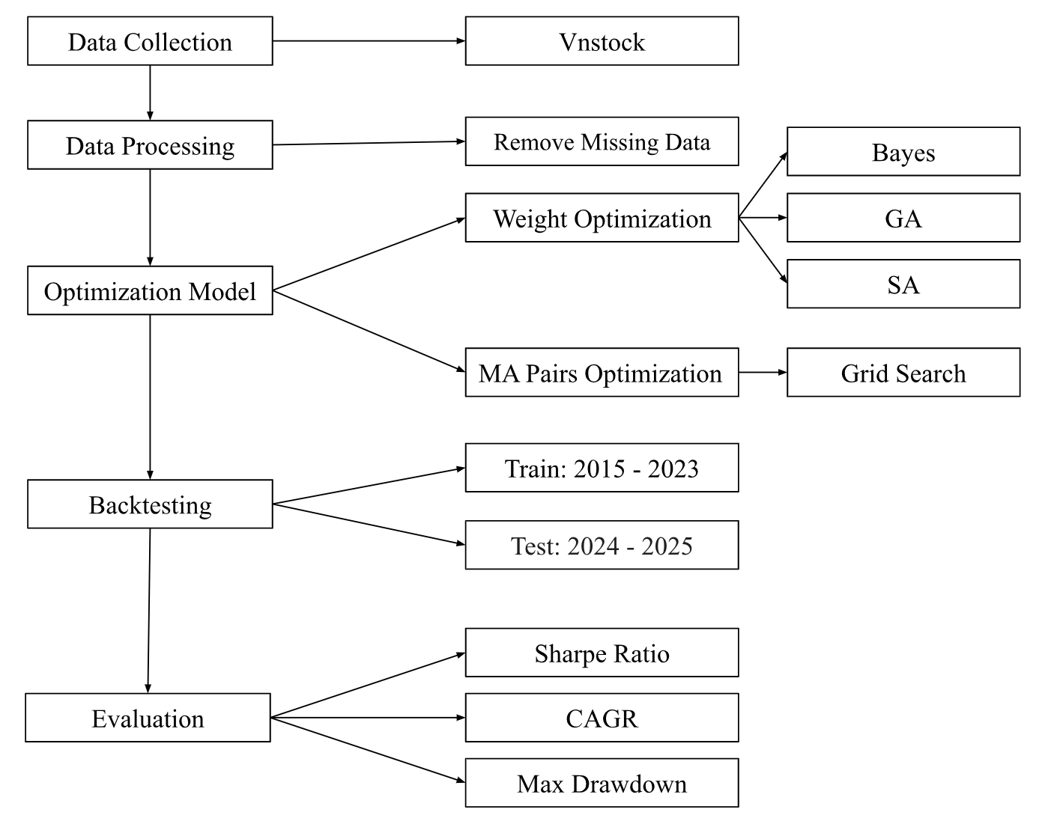
  - Data and Pre-processing
The study employs daily stock price data of 27 commercial banks listed on HOSE, HNX, and UPCoM during the period from 01/01/2015 to 20/08/2025. The banking sector is chosen due to its large market capitalization, high liquidity, and direct influence on overall market dynamics in Vietnam. Primary data is collected from the vnstock library and cross-verified with official disclosures from HOSE, HNX, and the State Securities Commission to ensure accuracy.
To ensure feasibility and continuity of the time series, the dataset undergoes three preprocessing steps. First, stocks with short listing periods or low liquidity are excluded to avoid distortions caused by insufficient data. Second, price adjustments are applied to account for corporate actions such as stock splits, rights issues, or stock dividends, thereby capturing actual returns. Third, time series across stocks are synchronized and missing values are filled using forward-fill methods to ensure continuity and comparability.
After preprocessing, the dataset is divided into two periods: the training set (2015–2022) for parameter optimization and model construction, and the testing set (2023–2025) for out-of-sample evaluation. This division captures an entire market cycle: post-crisis restructuring, rapid growth, disruptions from COVID-19 and the bond market shock, and credit recovery during 2023–2025. Overall, the dataset provides sufficient length for optimization while reflecting the distinctive dynamics of Vietnam’s stock market over the past decade.
  - Portfolio Weight Optimization
In this step, the study seeks the optimal portfolio weight vector that maximizes the Sharpe Ratio under the constraints of no short selling and weights summing to 100%. Three modern algorithms are implemented: Genetic Algorithm (GA), Simulated Annealing (SA), and Bayesian Optimization (BO).
GA is based on the principle of natural selection, where portfolios are treated as “individuals” undergoing selection, crossover, and mutation to form new generations. This process allows efficient exploration of the solution space and gradual convergence to the optimal solution.
SA leverages a cooling mechanism, allowing the acceptance of suboptimal solutions in the short run to escape local optima. This feature enhances the algorithm’s ability to reach global optima rather than being trapped in limited regions.
BO constructs a probabilistic model of the objective function, predicting promising trial points and focusing search efforts in potential regions. This significantly reduces the number of objective evaluations while maintaining high accuracy.
In addition to the three algorithms, the study retains the Equal Weighting (EW) portfolio as a baseline benchmark. This helps to clearly demonstrate the added value of optimization, since EW is widely used in practice but fails to fully capture the risk–return trade-off.
The outcome of this step is a set of optimized portfolios, each corresponding to one optimization method, ready to be combined with MA trading signals in the next stage.

Figure 2: Portfolio weight optimization diagram using GA and SA
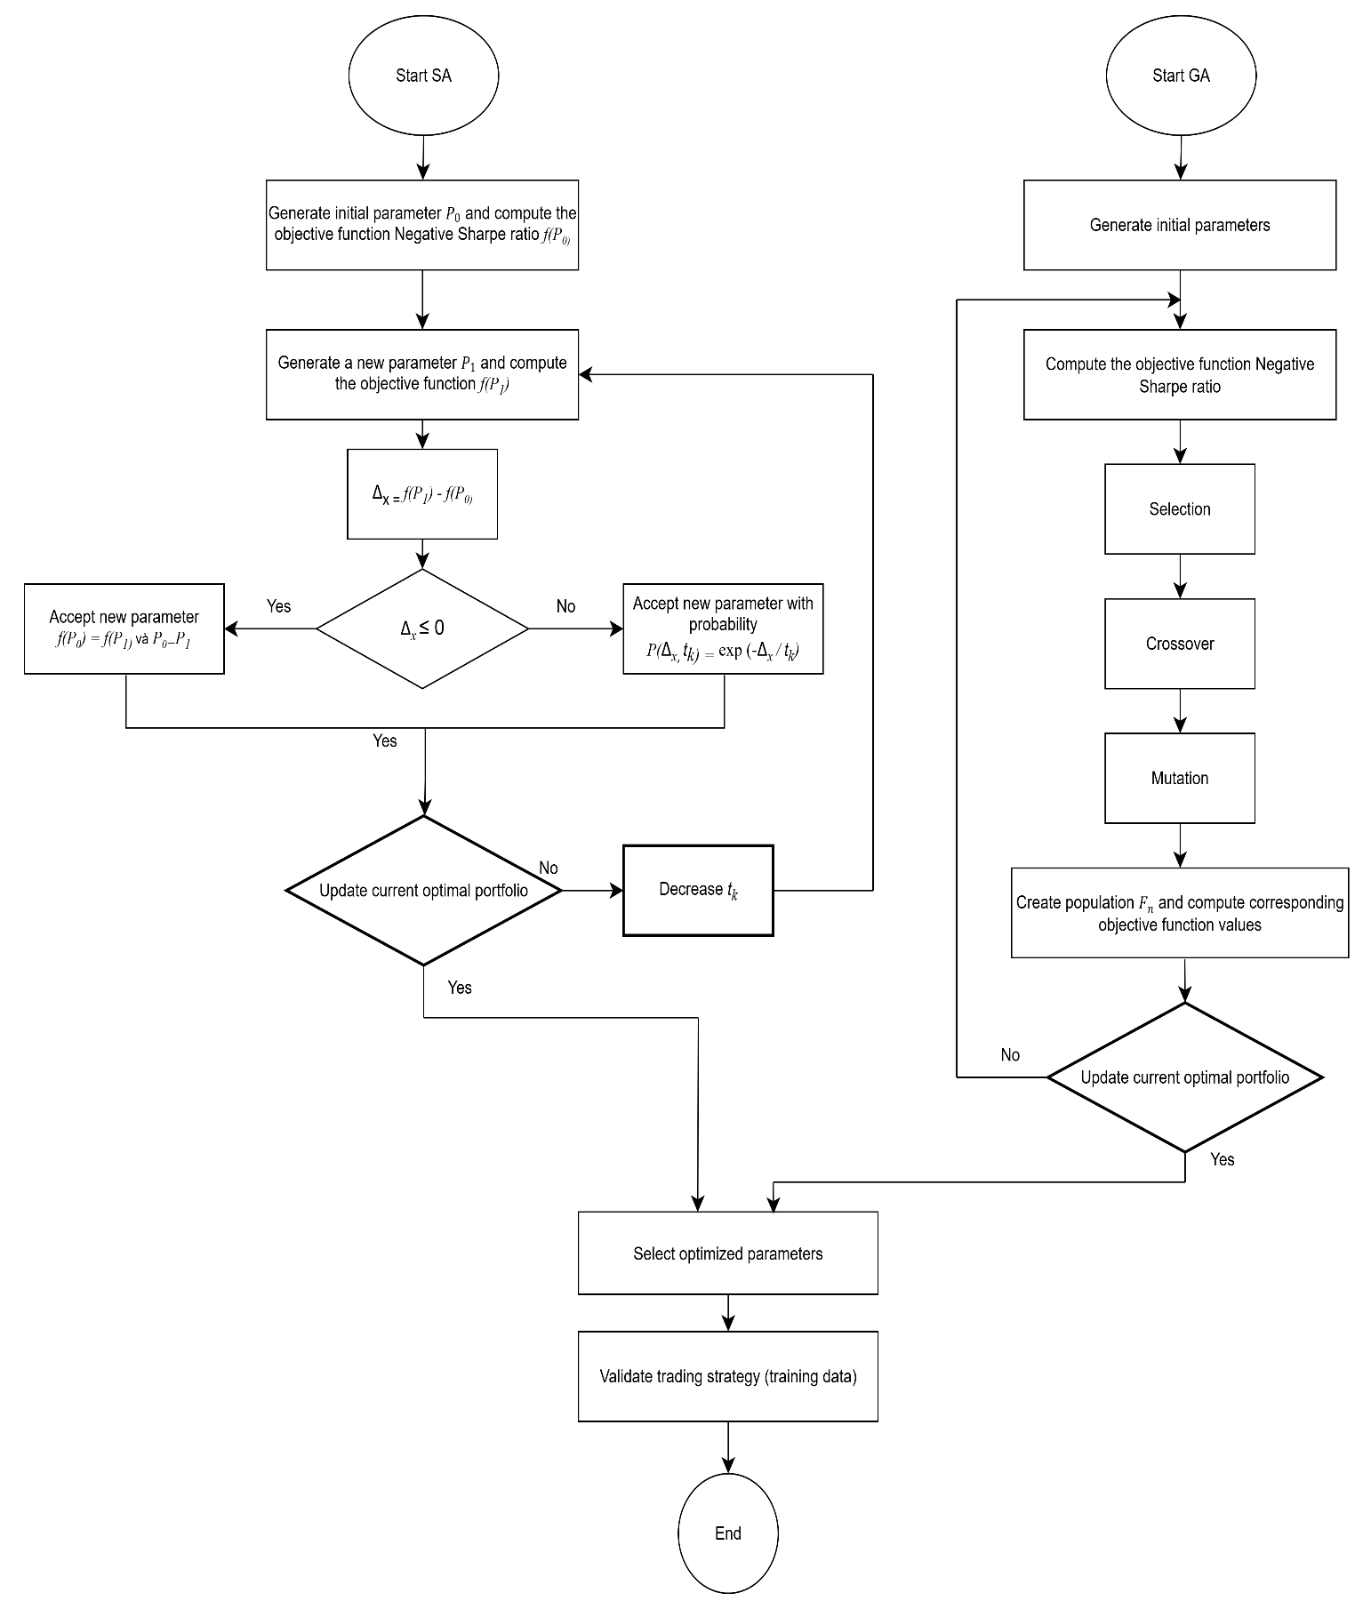
  - Optimization of Short–Long MA Parameters
In constructing trading signals based on moving averages (MA), a crucial step lies in selecting the appropriate window lengths for the short-term (Short) and long-term (Long) averages. In this study, three variants—SMA, EMA, and WMA—are considered, with the Short–Long parameters optimized through the Grid Search (GS) method. The mechanism of GS is straightforward: a grid of candidate values for Short (e.g., 5, 10, 15…) and Long (e.g., 51, 61, 71…) is defined, and all possible pairs are exhaustively scanned. For each pair, the algorithm generates buy/sell signals based on MA crossovers, computes daily returns, and evaluates performance using Sharpe Ratio, CAGR, and Maximum Drawdown. Since the entire parameter space is traversed, GS guarantees the identification of the global optimum within the search domain, without reliance on randomization.
The choice of GS over Bayesian Optimization, Genetic Algorithms, or Simulated Annealing is justified by the relatively small parameter space, which makes exhaustive search computationally feasible. GS also provides several important advantages: simplicity, transparency, and reproducibility in academic research; robustness against convergence to local optima common in heuristic methods; and ease of visualization through heatmaps or ranking tables, which facilitates observing optimization patterns (e.g., many stocks perform better when Short is small and Long is large).
Crucially, instead of relying on a single best-performing parameter set, this study selects the top 10% of Short–Long pairs with the highest Sharpe Ratios for each stock. This approach mitigates the risk of overfitting, since no single configuration remains consistently optimal across all market regimes. The retained optimal sets are subsequently used in the ensemble voting step, which produces the final trading signal for the portfolio.

  - Estimation and Backtesting Methods
After identifying the optimal parameters, the next step is backtesting to evaluate the practical effectiveness of the strategy. To ensure accuracy and consistency in data processing, this study adopts standardized estimation and validation methods widely applied in quantitative finance.
The dataset comprises daily closing prices of listed Vietnamese bank stocks on HOSE and HNX, collected via the vnstock API. The period from 01/2015–12/2023 is used for training, while 01/2024–08/2025 is reserved for out-of-sample testing. The main assumptions are as follows: the market operates 252 trading days per year; the risk-free rate is fixed at 3.5% per annum; transaction costs amount to 0.2% per state change; and trading signals are lagged by one day to eliminate look-ahead bias.
Signal generation formula:
$${\text{s}}_{\text{i,t}}\text{=}\left\{\begin{aligned}\text{1, if }{\text{MA}}_{\text{i,t}}^{\text{short}}\text{>}{\text{MA}}_{\text{i,t}}^{\text{Long}} \\ \text{0, otherwise }\end{aligned}\right.$$$$A buy position (1) is taken if the short−term MA exceeds the long−term MA; otherwise, the position remains flat (0).$$
Ensemble voting:
When applying the Top-K Voting mechanism, each stock i at time t is associated with K signals derived from the top K MA configurations. Formally:
$${\text{s}}_{\text{i,t}}^{\text{(k)}}\text{=}\left\{\begin{aligned}\text{1, if }{\text{MA}}_{\text{i,t}}^{\text{Short,(k)}}\text{>}{\text{MA}}_{\text{i,t}}^{\text{Long,(k)}} \\ \text{0, otherwise }\end{aligned}\text{, k=1,2,3,...k}\right.$$
The final signal is determined through majority voting:
$${\text{s}}_{\text{i,t}}\text{=}\left\{\begin{aligned}\text{1, if }\frac{\text{1}}{\text{k}}\sum_{\text{k=1}}^{\text{K}}{{\text{s}}_{\text{i,t}}^{\text{(k)}}\text{>0}} \\ \text{0, otherwise }\end{aligned}\right.$$In other words, if more than 50% of the top-K models issue a buy signal, the stock enters the portfolio; otherwise, it is excluded.
The strategy is further adapted to the practical conditions of the Vietnamese market. First, the T+2 settlement rule requires stocks purchased to be held for at least two sessions before sale. Second, a stop-loss mechanism is imposed: if returns fall to ≤ –7%, the position is immediately liquidated and cannot be re-entered within the next five sessions. Third, proceeds from a sale can only be redeployed after two sessions when cash is settled. In addition, actual stock weights are adjusted using an elasticity factor to account for capital locked under T+2. These elements ensure that the backtest results are not detached from market reality.
The backtesting procedure includes computing daily returns, portfolio turnover, transaction costs, profit/loss per stock, and cumulative net asset value (NAV). Performance is then evaluated using three key metrics: Sharpe Ratio, CAGR, and Maximum Drawdown. The Sharpe Ratio measures excess return per unit of risk, reflecting the balance between profitability and volatility. CAGR indicates the compound annual growth rate of portfolio value over time. Maximum Drawdown captures the worst peak-to-trough decline in NAV, highlighting downside risk during adverse periods. Together, these measures provide a comprehensive and balanced assessment of both return potential and risk exposure.
- Empirical results
  - Data Processing Outcomes
Historical daily closing prices (2015-01-01 to 2023-12-31) of banking sector stocks were collected and preprocessed under strict criteria: any ticker with more than 40% missing data across the sample window was excluded. After applying this filter, 17 valid tickers remained for analysis and subsequent optimization: ACB, BAB, BID, CTG, EIB, HDB, KLB, LPB, MBB, NVB, SHB, STB, TCB, TPB, VCB, VIB, VPB.
The excluded group comprised ABB, BVB, MSB, NAB, OCB, PGB, SGB, SSB, VAB, and VBB — all eliminated due to missing data exceeding the 40% threshold. This filtering ensured that the dataset maintained sufficient coverage and reduced biases from incomplete data, thereby providing a consistent foundation for optimization procedures.
  - Portfolio Weight Optimization
The study compared four portfolio weighting methods with the objective of maximizing the Sharpe Ratio: Simulated Annealing (SA), Genetic Algorithm (GA), Bayesian Optimization (BO), and Equal Weight (EW). Performance over the 2015–2023 training set is summarized as follows:

Table 1: Results of Portfolio Optimization Methods
Method | Expected Annual Return | Annual Risk | Sharpe Ratio
Simulated Annealing | 21.36% | 23.85% | 0.90
Genetic Algorithm | 21.54% | 24.19% | 0.89
Bayesian Optimization | 21.45% | 24.53% | 0.87
Equal Weight | 16.79% | 24.31% | 0.69
From these results, Simulated Annealing emerged as the most effective approach, yielding the highest Sharpe Ratio. The explanation lies in its mechanism: SA accepts temporary declines in the objective function during the search process, which allows it to escape local optima and better explore the solution space. Thus, SA achieves superior risk-adjusted performance compared with GA and BO, despite GA showing a slightly higher nominal return. The EW method performed considerably worse, illustrating that naive uniform allocation fails to exploit cross-stock performance differences.
Optimal weights derived from SA (only tickers with weight > 0): VCB 30.22%, LPB 19.93%, SHB 14.38%, EIB 13.25%, KLB 9.42%, NVB 9.03%, TPB 3.04%, BID 0.37%, STB 0.37%. The high allocation to VCB reflects its role as a large-scale bank with a strong brand and relatively stable performance, making it a preferred candidate for capital concentration under a Sharpe-maximizing criterion.
  - Optimization of Short–Long MA Parameters
With the objective of constructing trend-following signals, the study employs a Grid Search approach to identify optimal Short–Long MA pairs for each stock across three variants: SMA, EMA, and WMA. Rather than presenting the entire set of thousands of configurations, only the top 10% based on the Sharpe Ratio are extracted, with illustrative tables highlighting the best-performing configurations.

Table 2: Top 10% optimal SMA parameters obtained through Grid Search
Ticker | Short | Long | Sharpe Ratio
BID | 5 | 51 | 0.520603
EIB | 5 | 91 | 0.152116
KLB | 15 | 71 | 0.333403
LPB | 30 | 181 | 0.800140
NVB | 15 | 111 | 0.481559
SHB | 35 | 191 | 0.728590
STB | 20 | 61 | 0.434463
TPB | 20 | 81 | 0.855130
VCB | 5 | 51 | 0.673041

Table 3: Top 10% optimal EMA parameters obtained through Grid Search
Ticker | Short | Long | Sharpe Ratio
BID | 5 | 71 | 0.366678
EIB | 5 | 51 | 0.000000
KLB | 25 | 51 | 0.329662
LPB | 5 | 191 | 0.741045
NVB | 5 | 81 | 0.580002
SHB | 45 | 141 | 0.679324
STB | 10 | 51 | 0.398628
TPB | 25 | 51 | 0.728979
VCB | 10 | 51 | 0.545300

Table 4:Top 10% optimal WMA parameters obtained through Grid Search
Ticker | Short | Long | Sharpe Ratio
BID | 5 | 51 | 0.624697
EIB | 25 | 51 | 0.126628
KLB | 20 | 111 | 0.409220
LPB | 5 | 171 | 0.836375
NVB | 5 | 171 | 0.610087
SHB | 45 | 161 | 0.675578
STB | 5 | 51 | 0.445933
TPB | 15 | 51 | 0.811064
VCB | 5 | 51 | 0.698568

With SMA, TPB achieves a strong Sharpe Ratio at Short 20–Long 81, LPB performs well at Short 30–Long 181 with Sharpe ≈ 0.80, while VCB shows favorable results at Short 5–Long 51 with Sharpe ≈ 0.673. Similar patterns emerge for EMA and WMA: LPB tends to favor very short-term Short MAs combined with very long-term Long MAs, whereas VCB and several other stocks are better suited to short-term Short MAs with medium-term Long MAs. Overall, the results highlight significant heterogeneity across stocks and MA types, confirming that no single configuration can be universally applied. To address this, the study applies an Ensemble Top-K (K = 3) voting mechanism based on the top 10% configurations, which helps to reduce noise and limit overfitting risk
  - Backtesting Results on Training and Testing Sets
Backtesting was conducted under realistic Vietnamese market constraints: T+2 settlement, a –7% stop-loss rule with a five-session re-entry ban, 0.2% transaction cost per state change, and one-day lagged signals to avoid look-ahead bias. Both the training set (2015–2023) and the out-of-sample testing set (2024–08/2025) were evaluated.
Aggregate performance for the three MA methods:

Table 5: Portfolio Performance with SMA
Method | Period | Sharpe Ratio | CAGR | Max Drawdown
SMA | ALL | 1.377 | 24.03% | -16.21%
SMA | Train | 1.216 | 21.34% | -16.21%
SMA | Test | 2.278 | 39.70% | -10.52%

Table 6: Portfolio Performance with EMA
Method | Period | Sharpe Ratio | CAGR | Max Drawdown
EMA | ALL | 1.189 | 21.23% | -17.81%
EMA | Train | 1.015 | 18.35% | -17.81%
EMA | Test | 2.175 | 38.13% | -11.52%

Table 7: Portfolio Performance with WMA
Method | Period | Sharpe Ratio | CAGR | Max Drawdown
WMA | ALL | 1.398 | 23.56% | -14.89%
WMA | Train | 1.210 | 20.48% | -14.89%
WMA | Test | 2.424 | 41.72% | -9.43%
All three MA-based strategies delivered strong performance, but WMA stood out. It achieved the highest Sharpe Ratio across the full sample and particularly strong out-of-sample results (Sharpe 2.424, CAGR 41.72%, lowest Max Drawdown at –9.43%). Interestingly, performance on the test set consistently surpassed the training set for all MA variants. This pattern likely reflects favorable market conditions during 2024–08/2025, which may have amplified the effectiveness of trend-following strategies. Nevertheless, caution is warranted: unusually strong out-of-sample results may stem from temporary market cycles or sample-selection bias, raising questions about sustainability under adverse conditions.
- Conclusion
The study summarizes the entire process of optimizing stock trading strategies in the Vietnamese banking sector over the period 2015–2025, focusing on two main components: portfolio weight optimization using Simulated Annealing (SA) and parameter optimization of trading signals based on moving averages (SMA, EMA, WMA). The portfolio results indicate that SA delivers an expected annual return of 21.36%, annualized volatility of 23.85%, and a Sharpe ratio of approximately 0.90, with allocations concentrated in leading stocks such as VCB, LPB, SHB, and EIB. These are large-cap, highly liquid banks, accurately reflecting market reality, where major banks typically served as pillars during boom periods such as 2017–2018 and 2023–2025.
Regarding trading parameters, short windows of 5–25 days combined with long windows of 100–200 days yielded superior performance. Among the three variants, WMA demonstrated clear advantages due to its faster responsiveness to short-term fluctuations, with LPB, SHB, TPB, and VCB frequently appearing in top-performing configurations with high Sharpe ratios. Backtesting results further confirm the superiority of WMA, which achieved a Sharpe ratio of 1.40 (ALL) and 2.42 (Test), with a test CAGR of ~41.7% and a maximum drawdown of only –9.4%, outperforming SMA and EMA in both profitability and risk control. Notably, during 2023–2025, when monetary policy was eased and credit expanded significantly, the strategy’s performance surged. In contrast, adverse phases such as 2015–2016 (system restructuring) and 2022 (corporate bond crisis) led to deeper drawdowns. This clearly highlights the cyclical nature of quantitative models, which only fully realize their potential in favorable macroeconomic conditions.
From these findings, several recommendations are proposed. For individual investors, WMA should be prioritized over SMA/EMA given its superior performance and lower risk, while maintaining realistic expectations of a CAGR of 15–20% annually, instead of the ~40% observed in backtests. Strict adherence to trading discipline is essential, including a 10% stop-loss, compliance with T+2 settlement rules, avoiding short-selling, and limiting concentration in a few stocks to mitigate idiosyncratic risk.For fund managers, the model can be implemented alongside the VNFIN LEAD ETF to leverage passive capital flows, but must incorporate practical constraints such as minimum liquidity thresholds, maximum stock weights, and margin costs. More importantly, quantitative strategies should be complemented with fundamental analysis—covering net interest margins (NIMs), non-performing loans, and corporate bonds—to ensure investment decisions are more realistic and provide a comprehensive reflection of each bank’s performance.
As for future research directions, it is necessary to test model robustness through rolling Sharpe ratios, while experimenting with combinations of moving averages and other technical indicators such as RSI, MACD, and Bollinger Bands, or macroeconomic variables (interest rates, GDP, NPLs). In addition, assessing the impact of margin trading and leverage will better capture the behavior of Vietnamese investors, who often rely on borrowed capital to enhance returns.
Overall, the study demonstrates the feasibility and effectiveness of combining Simulated Annealing for portfolio optimization with an MA-Ensemble strategy for trading bank stocks. Nevertheless, limitations remain, as results are largely based on historical data, focused only on the banking sector, and not yet implemented in real trading systems. In the future, developing the model into an integrated application platform (web-based or mobile app) with real-time data connectivity, automated parameter optimization, and live trading signals would significantly enhance its practical value. Furthermore, extending the research to other sectors and incorporating additional indicators and macroeconomic variables would improve both the robustness and generalizability of the model.

REFERENCES
Breiman, L. (1996). Bagging predictors. Machine Learning, 24(2), 123–140.
Caruana, R., Niculescu-Mizil, A., Crew, G., & Ksikes, A. (2004). Ensemble selection from libraries of models. Proceedings of the Twenty-First International Conference on Machine Learning, 18.
Cerny, V. (n.d.). Thermodynamical Approach to the Traveling Salesman Problem: An Efficient Simulation Algorithm I. In JOURNAL OF OPTIMIZATION THEORY AND APPLICATIONS (Vol. 45, Issue l).
Dietterich, T. G. (2000). Ensemble methods in machine learning. International Workshop on Multiple Classifier Systems, 1–15.
Dinesh, S., Nithin Rao, R., Anusha, S. P., & Samhitha, R. (2021). Prediction of Trends in Stock Market using Moving Averages and Machine Learning. 2021 6th International Conference for Convergence in Technology, I2CT 2021. https://doi.org/10.1109/I2CT51068.2021.9418097
Freund, Y., & Schapire, R. E. (1997). A decision-theoretic generalization of on-line learning and an application to boosting. Journal of Computer and System Sciences, 55(1), 119–139.
Gai, K., Qiu, M., & Sun, X. (2018). A survey on FinTech. Journal of Network and Computer Applications, 103, 262–273.
Goldberg, D. E. (1989). Genetic algorithms in search, optimization, and machine learning. Addison-Wesley. (n.d.).
Hansun, S. (2013). A new approach of moving average method in time series analysis. 2013 International Conference on New Media Studies, CoNMedia 2013. https://doi.org/10.1109/conmedia.2013.6708545
Holland, J. H., & Book, A. B. (n.d.). ADAPTATION IN NATURAL AND ARTIFICIAL SYSTEMS.
Johnston, F. R., Boyland, J. E., Meadows, M., & Shale, E. (1999). Some properties of a simple moving average when applied to forecasting a time series. Journal of the Operational Research Society, 50(12). https://doi.org/10.1057/palgrave.jors.2600823
Kan, N. H. L., Cao, Q., & Quek, C. (2024). Learning and processing framework using Fuzzy Deep Neural Network for trading and portfolio rebalancing. Applied Soft Computing, 152, 111233.
Kirkpatrick, S., Gelatt, ; C D, & Vecchi, ; M P. (1983). Optimization by Simulated Annealing. In New Series (Vol. 220, Issue 4598).
Lê, H. A., & Nguyễn, L. T. T. (2024). Ứng dụng phương pháp học máy trong giao dịch chứng khoán theo chỉ báo bằng ngôn ngữ lập trình Python. Tập San Khoa Học và Kỹ Thuật Trường Đại Học Bình Dương, 7(1). https://doi.org/10.56097/binhduonguniversityjournalofscienceandtechnology.v7i1.212
Leles, M. C. R., Sbruzzi, E. F., de Oliveira, J. M. P., & Nascimento, C. L. (2019). Trading switching setup based on reinforcement learning applied to a multiagent system simulation of financial markets. 2019 IEEE International Systems Conference (SysCon), 1–8.
Liyanagamage, C., & Madusanka, P. H. A. C. (2021). Modeling for Stock Price Forecasting in Colombo Stock Exchange: An Historical Analysis of Stock Prices. International Journal of Applied Economics, Finance and Accounting, 9(1). https://doi.org/10.33094/8.2017.2021.91.1.7
Martinez-Munoz, G., & Suárez, A. (2007). Using boosting to prune bagging ensembles. Pattern Recognition Letters, 28(1), 156–165.
Mazumder, S., Neogy, S., & Das, S. (2023). Simple Moving Average (SMA) Crossover Strategy with Buy Sell Indicator. Advancement in Management and Technology (AMT), 3(4), 26–40.
Metaxiotis, K., & Liagkouras, K. (2012). Multiobjective evolutionary algorithms for portfolio management: A comprehensive literature review. Expert Systems with Applications, 39(14), 11685–11698.
Nguyen, H. (2015). A combination of time series models and technical analysis for Vietnamese stock trading. Working Paper.
Ojha, A., & Saxena, V. (2023). Understanding Stock Market Trends Using Simple Moving Average (SMA) and Exponential Moving Average (EMA) Indicators. Proceedings of International Conference on Contemporary Computing and Informatics, IC3I 2023. https://doi.org/10.1109/IC3I59117.2023.10398001
Raudys, A., & Pabarškaitė, Ž. (2018). Optimising the smoothness and accuracy of moving average for stock price data. Technological and Economic Development of Economy, 24(3), 984–1003. https://doi.org/10.3846/20294913.2016.1216906
Širůček, M., & Křen, L. (2015). Application of Markowitz portfolio theory by building optimal portfolio on the US stock market. Acta Universitatis Agriculturae et Silviculturae Mendelianae Brunensis, 63(4). https://doi.org/10.11118/actaun201563041375
Surtee, T. G. H., & Alagidede, I. P. (2023). A novel approach to using modern portfolio theory. Borsa Istanbul Review, 23(3). https://doi.org/10.1016/j.bir.2022.12.005
Wolpert, D. H. (1992). Stacked generalization. Neural Networks, 5(2), 241–259.
Xiao, C., Xia, W., & Jiang, J. (2020). Stock price forecast based on combined model of ARI-MA-LS-SVM. Neural Computing and Applications, 32(10). https://doi.org/10.1007/s00521-019-04698-5
Zhang, D., & Zhang, X. (2009). Study on Forecasting the Stock Market Trend Based on Stochastic Analysis Method. International Journal of Business and Management, 4(6). https://doi.org/10.5539/ijbm.v4n6p163
Zhou, Z.-H. (2025). Ensemble methods: foundations and algorithms. CRC press.

